Blood Bank Management System

Project submitted to the

SRM University – AP, Andhra Pradesh

for the partial fulfilment of the requirements to award the degree of

**Bachelor of Technology**

In

**Computer Science and Engineering**

**School of Engineering and Sciences**

Submitted by

K. Anudeep - AP21110010083

T. Kumar Varma – AP21110010106

J. varshith – AP21110010107

Vijaya Vyshnavi.M– AP21110010119

Under the Guidance of

**Ajay B**

**SRM University–AP**

**Neeru Konda, Mangalagiri, Guntur**

**Andhra Pradesh – 522 240**

**May, 2024**

# Certificate

Date: 06-May-2024

This is to certify that the work present in this Project entitled “**Blood Bank Management System**” has been carried out by K. Anudeep, T. Kumar Varma, J. varshith, Vijaya Vyshnavi under my/our supervision. The work is genuine, original, and suitable for submission to the SRM University – AP for the award of Bachelor of Technology/Master of Technology in **School of Engineering and Sciences**.

**Supervisor**

(Signature)

Prof. / Dr. Ajay

Designation,

Affiliation.

# Acknowledgments

We thank the people who were a part of this project in numerous ways, people who gave their unending support right from the stage the project idea was conceived. The four things that go on to make a successful endeavour are dedication, hard work, patience and correct guidance. We would like to thank our mentor for all the help he has rendered to ensure the successful completion of the project and gave his suggestions for developing our project in a better way. He was very much kind enough to give us an idea and guide us throughout our project work. Last but not the least I would like to thank all our friends for their support, and all others who have contributed to the completion of this project directly or indirectly.

# Table of Contents

Certificate **1**

Acknowledgments **3**

Table of Contents **5**

Abstract **7**

Introduction **1**

**Requirement Specification** **1**

**Detailed Design** **2**

Admin: 2

Donor: 2

Patient: 3

**Implementation** **5**

Schemas used 5

ER Diagram 6

**Testing** **8**

PHP code for home page 8

Home page 10

Admin login page 11

Admin Dashboard Page 11

Donors list page 12

Donor Dashboard 12

Blood Donation Page 13

Request Blood Page 13

**Conclusion** **15**

**References** **17**

# Abstract

This project is meticulously designed to serve as a comprehensive repository for all pertinent data concerning blood donors, patient information, and the inventory of blood groups within the blood bank. Its primary objective is to foster transparency within the realm of blood donation and distribution, streamlining the process of acquiring blood from the bank while safeguarding against corruption. By implementing robust management protocols, this system aims to enhance the efficiency and effectiveness of blood bank operations, ensuring seamless coordination between donors, recipients, and healthcare providers.

# List of Tables

Table 1. Text for an example table…………………………..…………………………..10

# List of Figures

Fig 1: ER Diagram………………………...………………………6

Fig 2: Home Page………………………...……………………….10

Fig 3: Admin Login Page………………………...……………….11

Fig 4: Admin Dashboard Page………………………...………….11

Fig 5: Donors List Page………………………...…………………12

Fig 6: Donor Dashboard………………………...………………...12

Fig 7: Blood Donation Page………………………...……………..13

Fig 8: Request Blood Page………………………...……………….13

# 8.Introduction

The BLOOD BANK MANAGEMENT SYSTEM project is a great project. This project is designed for successful execution of blood bank management system functionality.

The basic building aim is to provide online blood bank service to the people. It is a browser-based system that is designed to store, process, retrieve and analyse information concerned with the administrative and inventory management within a blood bank system.

This project is built to maintaining all the information pertaining to blood donor, patient information and the stock of all the blood group available in the bank. Aim is to provide transparency in this field, make the process of obtaining blood from a blood bank hassle free and corruption free and make the system of blood bank management effective.

The Blood bank system project report contain information related to blood like –

* Blood group
* Available blood stock
* Donor detail
* Patient detail

This system is used for maintain whole information about admin, donors, blood stock and patients.

# 9.Requirement Specification

* Text editor (any)
* Web browser (any)
* Xampp local serve

# 10.Detailed Design

There are mainly 3 modules in this project.

* Admin
* Donors
* Patients

## 1.Admin:

Admin is the main role in the system, admin can manage all the activities like managing donor, patients and blood stock etc.

Admin can perform –

1. Check the available stock of the blood
2. Manage donors
3. Manage patients
4. Manage blood donations
5. Manage blood requests
6. Logout

Admin can manage donations like he can accept or reject the donations request based on the donor details. He can accept or reject blood requests based on the blood stock available. Admin can manage all the donor and patient. He can edit the details of donors or patients. He can delete any donor or patients.

## 2.Donor:

Donor is also an important role in the system. If any person or donor want to donate the blood, he or she has to register himself first. Once he or she register he/she can login to the system where he can manage or execute donor’s activities like –

1. Donate blood
2. Manage donation history
3. Check the status of donation requests
4. Logout

Once donor make a request to donate blood, admin has to take action on that request based on the donor details. Once admin accept or reject that donation request, it will be automatically update to the donor dashboard. Donor can check the status of his request. Once his donation request is accepted, he or she will be called to donate blood at the specified donation camp.

## 3.Patient:

Patient is the one who is suffering from any disease and he need blood. He can go to the system and register himself as a patient. Once he registers, he/she can login to the system and access patient dashboard.

Patient can perform some activities like –

1. Make blood request
2. Check the status of his request
3. Logout

Once the patient makes a request for blood, he has to provide the basic details like the no of blood units required, blood group, disease etc.

Once he makes a request, it will be reflected in the admin dashboard. Now admin has to take action on that request. Admin can accept or reject that request based on the patient details or blood stock available in the system.

# 11.Implementation

For implementing this project, we used the following languages

1. HTML
2. CSS
3. JavaScript
4. jQuery
5. PHP
6. MySQL

## Schemas used

**Admins**

|  |  |  |  |  |
| --- | --- | --- | --- | --- |
| id(int) | name(varchar) | email(varchar) | password(varchar) | mobile(bigint) |

**Donors**

|  |  |  |  |  |
| --- | --- | --- | --- | --- |
| id(int) | name(varchar) | email(varchar) | password(varchar) | mobile(bigint) |

**Patients**

|  |  |  |  |  |
| --- | --- | --- | --- | --- |
| id(int) | name(varchar) | email(varchar) | password(varchar) | mobile(bigint) |

**Donation**

|  |  |  |  |  |  |
| --- | --- | --- | --- | --- | --- |
| id(int) | donor_id(int) | blood_group(varchar) | no_units(int) | disease(varchar) | status(int) |

|  |  |  |  |  |  |
| --- | --- | --- | --- | --- | --- |
| id(int) | patient_id(int) | no_units(int) | blood_group(varchar) | reason(varchar) | status(int) |

**Requests**

**Stocks**

|  |  |  |
| --- | --- | --- |
| sno(int) | blood_group(varchar) | stock(int) |

## ER Diagram

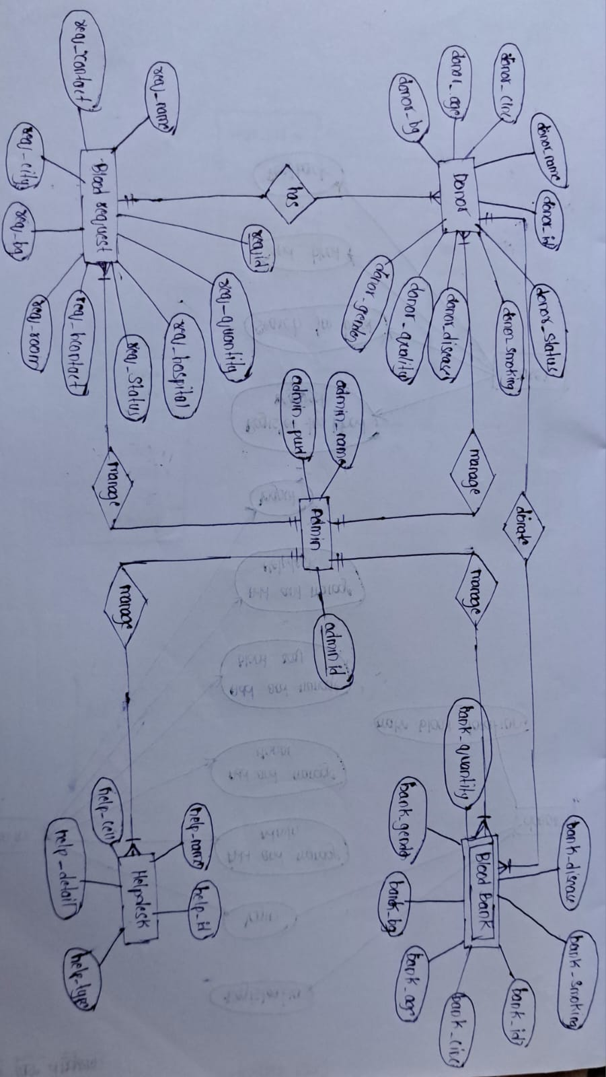

**Fig 1: ER Diagram**

# 12.Testing

# 2.PHP code for home page

<!DOCTYPE *html*>

<html *lang*="en">

<head>

<meta *charset*="UTF-8">

<meta *http-equiv*="X-UA-Compatible" *content*="IE=edge">

<meta *name*="viewport" *content*="width=device-width, initial-scale=1.0">

<title>Blood Bank Management</title>

*<!-- Bootstrap files -->*

<link *rel*="stylesheet" *href*="bootstrap/css//bootstrap.min.css">

<script *src*="bootstrap/js/bootstrap.min.js"></script>

*<!-- External CSS file -->*

<link *rel*="stylesheet" *href*="css/styles.css">

</head>

<body>

<nav *class*="navbar navbar-expand-lg navbar-dark bg-danger">

<a *class*="navbar-brand" *href*="index.php">Blood Bank Management System</a>

<button *class*="navbar-toggler" *type*="button" *data-toggle*="collapse" *data-target*="#navbarNav" *aria-controls*="navbarNav" *aria-expanded*="false" *aria-label*="Toggle navigation">

<span *class*="navbar-toggler-icon"></span>

</button>

<div *class*="collapse navbar-collapse" *id*="navbarNav">

<ul *class*="navbar-nav">

<li *class*="nav-item">

<a *class*="nav-link" *href*="index.php">Home</a>

</li>

<li *class*="nav-item">

<a *class*="nav-link" *href*="admin/login.php">Admin</a>

</li>

<li *class*="nav-item">

<a *class*="nav-link" *href*="donor/login.php">Donor</a>

</li>

<li *class*="nav-item">

<a *class*="nav-link" *href*="patient/login.php">Patient</a>

</li>

</ul>

</div>

</nav>

*<!-- Main content -->*

<div *class*="container-fluid" *style*="margin:50px;">

<div *class*="row container" *style*="text-align: justify;">

<div *class*="col-md-8 mx-auto content-left">

<h4>What is Blood Bank Management System?</h4>

<p>

Blood bank is a place where blood bag that is collected from blood donation events is stored in one place. The

term “blood bank” refers to a division of a hospital laboratory where the storage of blood product occurs and where

proper testing is performed to reduce the risk of transfusion related events

</p>

</div>

<div *class*="col-md-3 content-right">

<img *class*="img-fluid" *src*="../BBMS/images/image1.jpg" *height*="auto" *width*="70%">

</div>

</div>

</div>

<div *class*="container-fluid">

<div *class*="row">

<div *class*="col-md-10 m-auto" *style*="text-align: justify;">

<h4>What is there in this website?</h4>

<p>

There are mainly 3 modules in this website.</br>

Admin:</br>

Admin is the main role in the system, admin can manage all the activities like managing

donor, patients and blood stock etc</br>

Donor:</br>

Donor is also an important role in the system. If any person or donor want to donate the

blood, he or she has to register himself first. Once he or she register he/she can login to

the system</br>

Patient:</br>

Patient is the one who is suffering from any disease and he need blood. He can go to the

system and register himself as a patient. Once he registers, he/she can login to the

system and access patient dashboard

</p>

</div>

</div>

</div>

<div *class*="container-fluid" *style*="margin-bottom: 5%;">

<div *class*="row">

<div *class*="col-10  m-auto">

<h4>Our centers?</h4>

<div *class*="card">

<h4>Vijayawada</h4>

<hr>

<p>Mg road,opposite Pvp mall,Vijayawada-12,Andhra Pradesh.</p>

</div>

<div *class*="card">

<h4>Guntur</h4>

<hr>

<p>Brodipet,Road number-12,Andhra Pradesh.</p>

</div>

<div *class*="card">

<h4>Hyderabad</h4>

<hr>

<p>Madhapur,opposite metro stop,Hyderabad,Telangana.</p>

</div>

</div>

</div>

</div>

<div *class*="container-fluid">

<div *class*="row">

<div *class*="col-md-12 bg-danger footer">

&copy 2022 CSEtutorials.com

</div>

</div>

</div>

</body>

</html>

## Home page

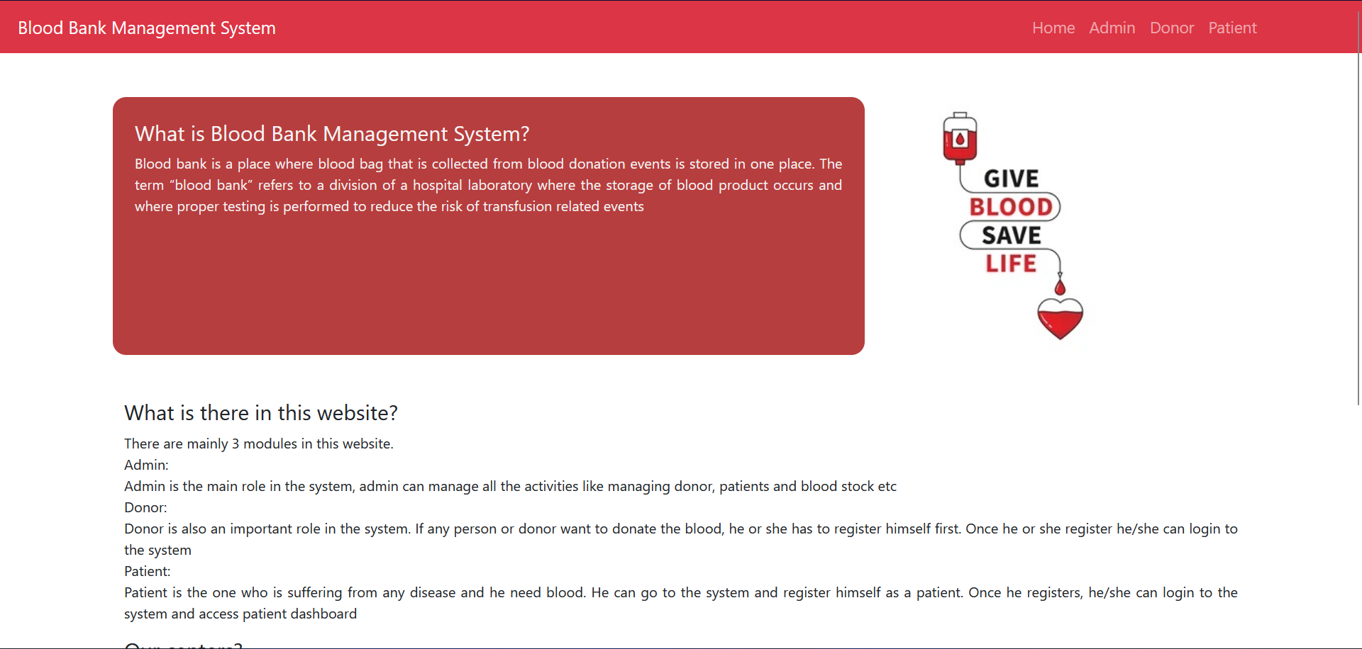

**Fig 2: Home Page**

## Admin login page

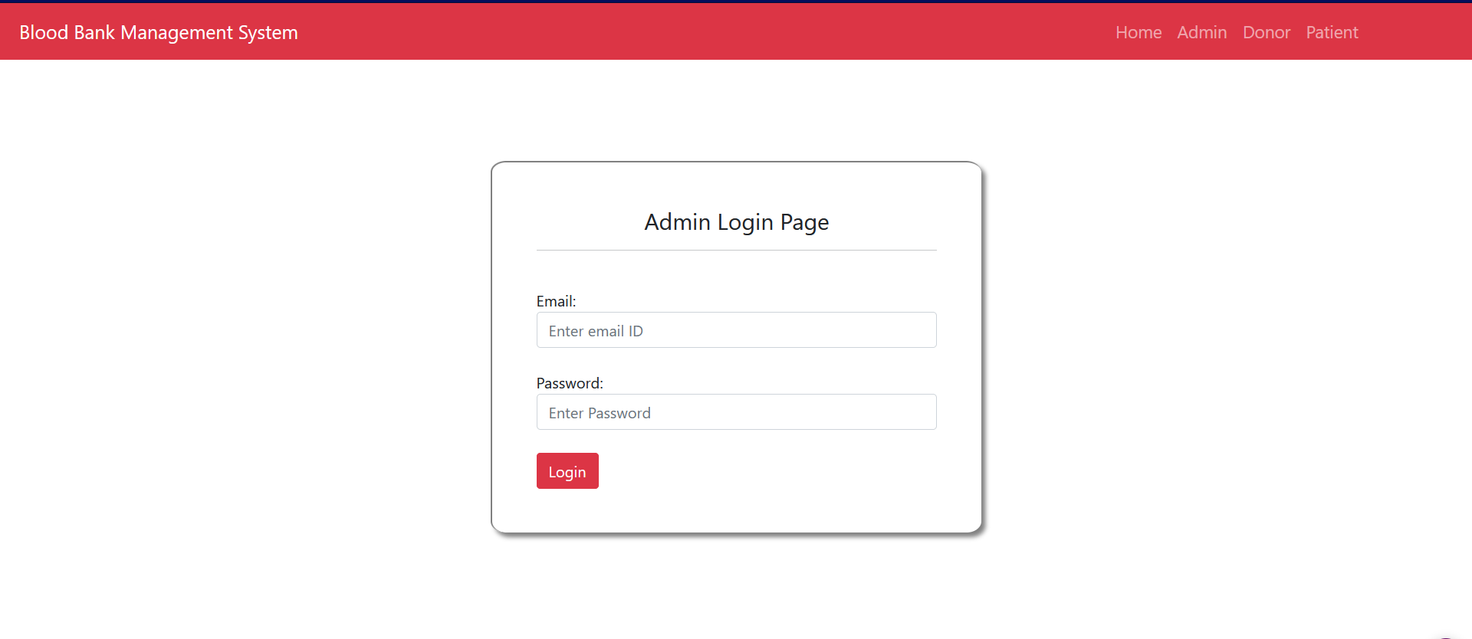

**Fig 3: Admin Login Page**

## Admin Dashboard Page

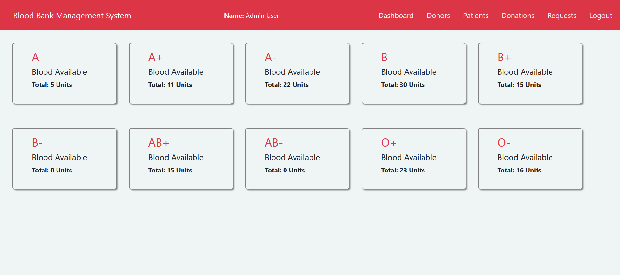

**Fig 4: AdminDashboard Page**

## Donors list page

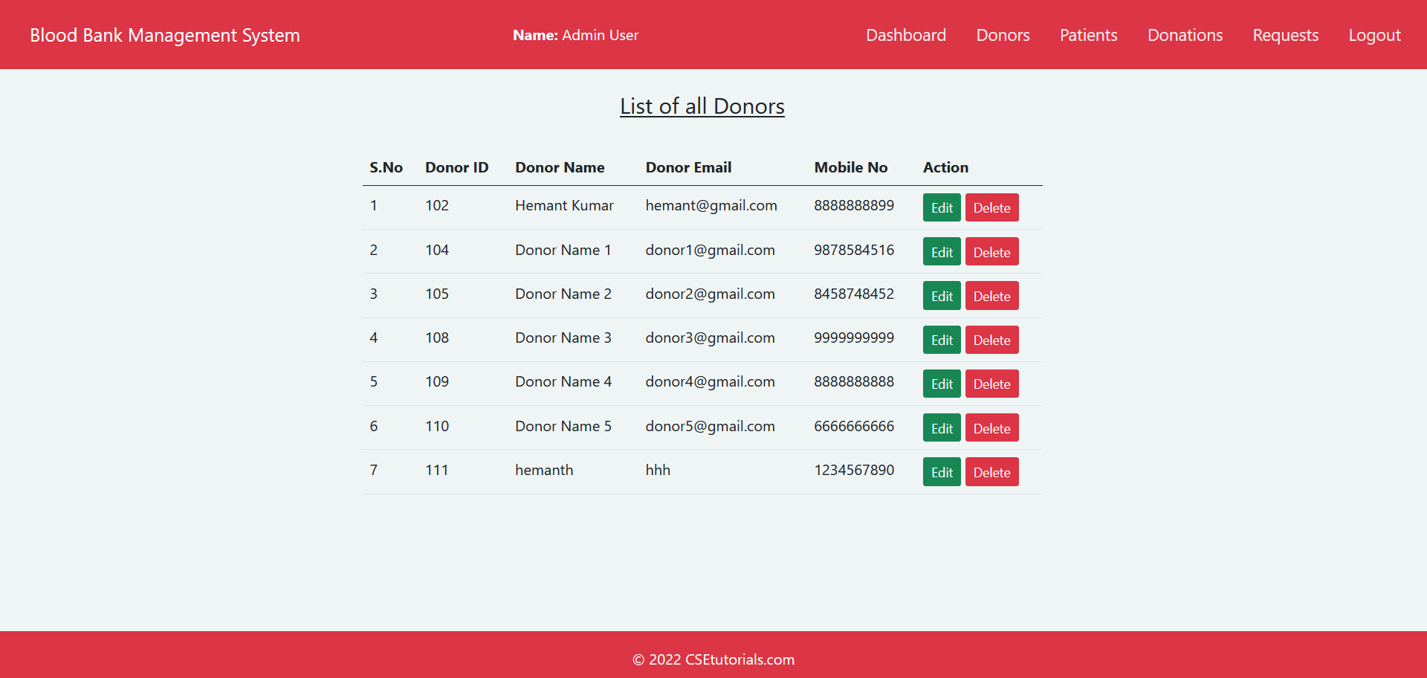

**Fig 5: Donors List Page**

## Donor Dashboard

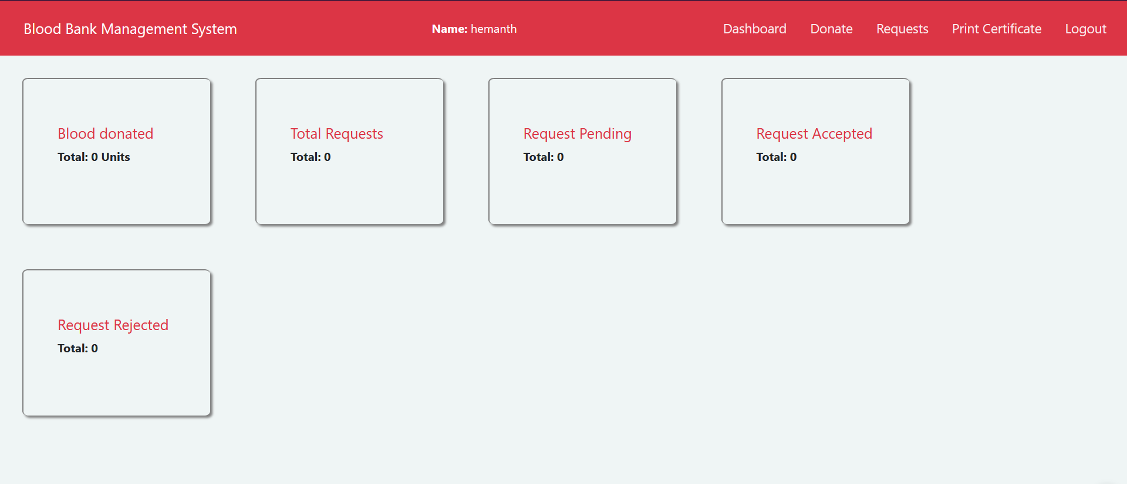

**Fig 6: Donor Dashboard**

## Blood Donation Page

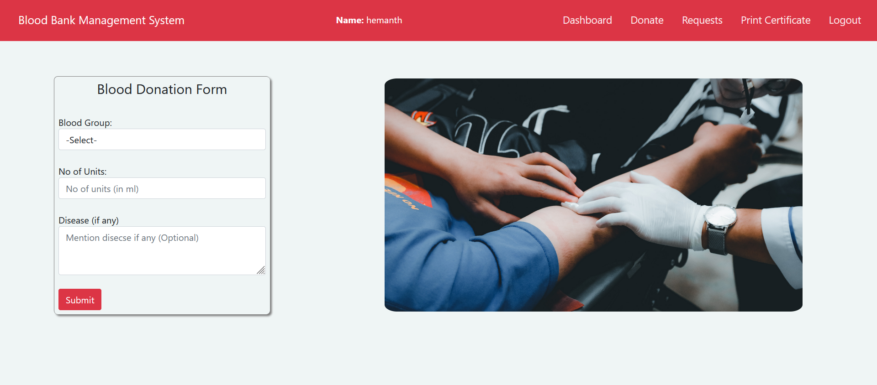

**Fig 7: Blood Donation Page**

## Request Blood Page

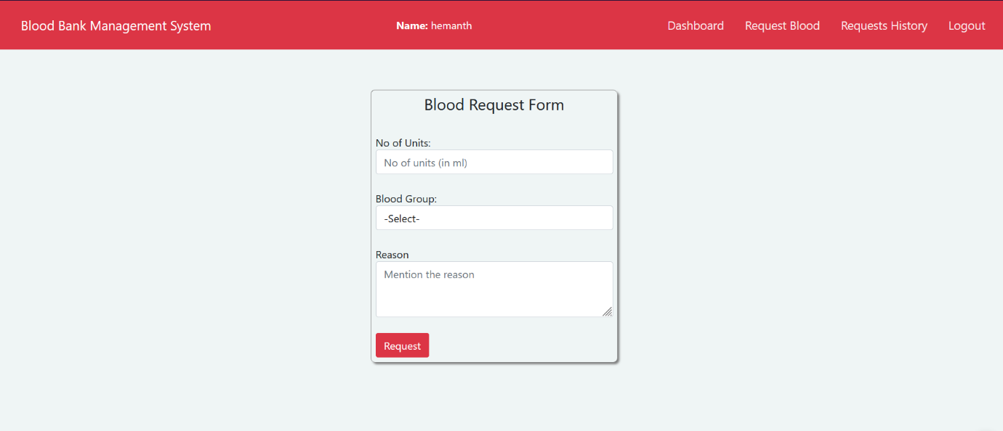

**Fig 8: Request Blood Page**

**13.Conclusion**

With the theoretical inclination of our syllabus, it becomes very essential to take the utmost advantage of any opportunity of gaining practical experience that comes along. The building blocks of this Major Project “Blood Bank Management System” was one of these opportunities. It gave us the requisite practical knowledge to supplement already taught theoretical concepts thus making us more competent as a computer engineer. The project from a personal point of view also helped us in understanding many aspects. The project also provided us the opportunity of interacting with our teacher and to gain from their best experience.

**14.Reference**

1. The Joy of PHP Programming: A Beginner’s Guide – by Alan Forbes

2. SQL: QuickStart Guide – The Simplified Beginner’s Guide To SQL

3. G. Muddu Krishna; S. Nagaraju(2016),“Design and implementation of short message service (SMS) based blood bank”, 2016 International Conference on Inventive Computation Technologies (ICICT)

4. “A Study on Blood Bank Management System” by A. Clemen Teena, K. Sankar and S. Kannan, Department of MCA, Bharath University, Selaiyur, Chennai-73, Tamil Nadu, India

5. The Optimization of Blo od Donor Information and Management System by Technopedia P. Priya1, V. Saranya2, S. Shabana3, Kavitha Subramani4 Department of Computer Science and Engineering, Panimalar Engineering College, Chennai, India 1, 2, 3,

6.Anish Hamlin M R, Albert Mayan J (2016), “Blood Donation And Life Saver-Blood Donation App”, 2016 Internation al Conference on Control , Instrumentatio n, Communication and Computational Technologies (ICCICCT)

7.“Android Blood Bank” by Prof. Snigdha1, Varsha Anabhavane2, Pratiksha lokhande3, Siddhi Kasar4, Pranita More5 Lecturer, Information Technology, Atharva College of Engineering, Mumbai, India 1 Student, Information Technology, Atharva College of Engineering, Mumbai, India 2,3,4,5